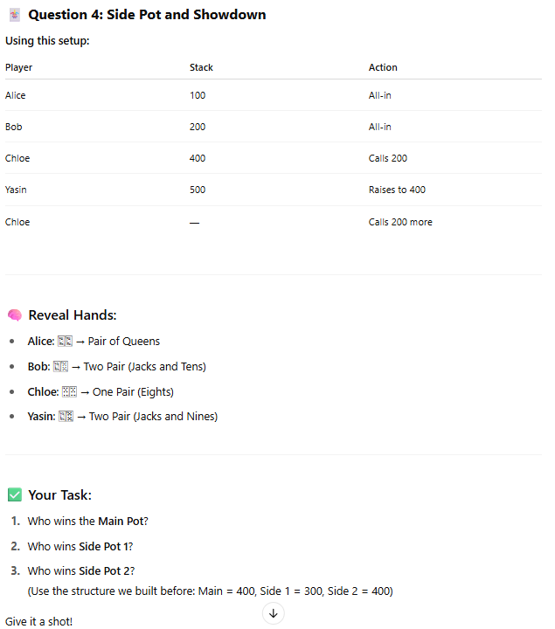

**🃏 Question 5: Multi-Side Pot Showdown**

**🔧 Setup:**

| **Player** | **Stack** | **Action** |
| --- | --- | --- |
| Alice | 150 | All-in |
| Bob | 300 | All-in |
| Chloe | 500 | Calls 300 |
| Yasin | 700 | Raises to 500 |
| Zara | 1000 | Calls 500 |
| Firas | 1200 | Calls 500 |

🔔 All players call **as much as they can** to stay in the hand.

**💬 Reveal Hands:**

* **Alice**: 🂭🂫 → Pair of Queens
* **Bob**: 🂽🂻 → Two Pair (Jacks and Tens)
* **Chloe**: 🂴🂤 → One Pair (Fours)
* **Yasin**: 🃍🂺 → Two Pair (Jacks and Nines)
* **Zara**: 🃎🃑 → Ace High
* **Firas**: 🂲🂲 → Three of a Kind (Twos)

**🧠 Community Cards (Flop + Turn + River):**

* 🂾 🂻 🂩 🃊 🃉
* (Ten, Jack, Nine, Queen, Two)

**🎯 Your Task:**

Determine:

1. ✅ The **Main Pot** amount and eligible players
2. ✅ All **Side Pots** (amounts + eligibility)
3. ✅ Who wins each pot based on the hands shown

Use a table like:

| **Pot** | **Amount** | **Eligible Players** | **Winner(s)** |
| --- | --- | --- | --- |
| Main Pot | ???? | ??? | ??? |
| Side Pot 1 | ???? | ??? | ??? |
| Side Pot 2 | ???? | ??? | ??? |
| ... | ... | ... | ... |